TEAM PROJECT FORDCS V1.0

EDUp

FORDCS V1.0 Project Document

version v2022.07

By: Ömer Karacan, MSc

Project Owner: Ömer Karacan, MSc

Vienna, 03.07.2022

Table of Contents

1. Project Plan 3

1.1. Statement of Work 3

1.2. Customer Requirements 3

1.3. Technical Scope 3

1.4. Release Plan 4

1.5. Artefacts 4

1.6. Additional Considerations 4

2. Development 4

2.1. System Requirements 5

2.2. System/Software Architecture 5

2.3. Integration Test Cases 5

2.4. Validation Test Cases 5

3. Delivery 6

3.1. DevOps Setup 6

3.2. Product Release 6

3.3. Quality Assurance 6

4. References 6

5. <Annex - > <topic name>> 6

# Project Plan

Create an Overview Pictrure using **visual notation** like here

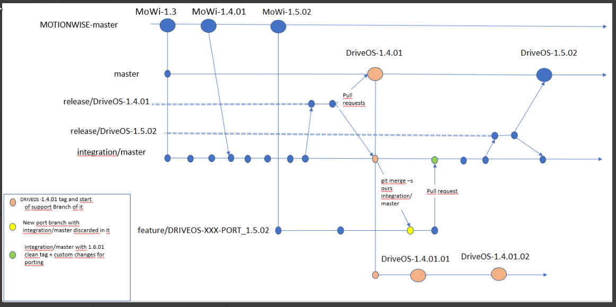

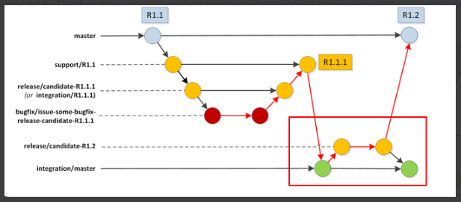

# Statement of Work

<The motivation of this section is "Why are we doing this project?". This introductory part describes roughly the motivation and individual incentives of the authors!>

This section also describes roughly the consensus of this document to the customer requirements document, which is the initiator of this project.

This document specifies all organizational elements and technical context that are needed to manage and develop the project.>

# Customer Requirements

<review>

<The motivation of this section is to summarize the essential customer requirements (expectations) and provisions, if any. Essential requirements are such that are declared as critical and most important by customer.

side-notes:

* There are topics that their incompleteness or misinterpretation may have significant consequences. Such topics (issues) should be eliminated through assumptions and documented in section “Assumptions and Preconditions”!
* There are topics that can be conceptually and physically materialized in different ways. Such should be described in section "Additional Considerations".>

<In general, reference(s) to customer requirements document(s) should be sufficient for this section and should be striven for.>

The customer requirements document is sufficient for this section:

* EDUp-ford-charging-station-customer-needs.v2022.03-1.pptx

Th customer delivers a swagger interface description to define the requested

List of artifacts delivered by customer, if any!

|  |  |  |  |  |
| --- | --- | --- | --- | --- |
| Artifact Short Name | Content Information | Version | Schedule | Responsible |
|  |  |  |  |  |
|  |  |  |  |  |

Table 1 Customer provisions

# Technical Scope

<review>

<The motivation of this section is to describe roughly the technical solution concept covering the customer technical requirements!

# Release Plan

<review>

<The motivation of this section is to describe all project management defined precautions for a successful project development and delivery!>

<This section contains the following mandatory sub-sections (optional if the corresponding topic is described in another document. The link should be included here!]):

* Roles and Responsibilities
* Project Plan
* Assumptions and Preconditions
* Continuous Integration (DevOps) 🡪 CI/CD may be solely described in a main section!>

# Artefacts

<new content>

# Additional Considerations

<The motivation of this section is to provide a section for any topic that is not associated with the previous sections, but it should be considered because of its importance (forgetting may cause problems for the project).>

<This section may contain the following sub-sections

* Risk Assessment: The motivation of this section is to identify risks, and plan and execute mitigation activities as soon as possible!   
  side-note: The risks are used to prioritize the testing cases and code coverage thresholds!
* Fundamental references: The motivation of this section is to emphasize specific references that are used throughout the project like Spring help pages! Utilizing one source ensures the all-over consistency!>

# Development

<review>

<This section contains the following mandatory sub-sections (optional if the corresponding topic is described in another document. The link should be included here!]):

* Hardware (physical) architecture (EDUp Architecture Design Specification)
* Software (layered) architecture (EDUp Architecture Design Specification)
* Basic web services and domain model (EDUp System Requirements Specification)
* Basic system functionality (EDUp System Requirements Specification)
* Basic production test setup (Validation Test Specification)>

**Hardware (physical) architecture**

See (EDUp Architecture Design Specification)

**Software (layered) architecture (EDUp Architecture Design Specification)**

See (EDUp Architecture Design Specification)

**Basic system functionality**

**Basic web services and domain model**

See (EDUp System Requirements Specification based on Swagger interface from Swagger Hub, see customer requirements document)

**Basic production test setup**

See (Validation Test Specification)

The system software is **swagger enabled**! The generated “swagger-io.html” provides the possibility to conduct manually acceptance tests!

# System Requirements

<new content>

# System/Software Architecture

<new content>

# Integration Test Cases

<new content>

# Validation Test Cases

<new content>

# Delivery

<new content>

# DevOps Setup

<This section contains the following mandatory sub-sections (optional if the corresponding topic is described in another document. The link should be included here!]):

* Development IDE Tools (to code the algos)
* Basic SW packages (to implement the architecture and services)
* Basic SW production setup (to produce executables)>

# Product Release

<review>

<The motivation of this section is to describe what should be delivered how!>

<This section may contain the following sub-sections

* Delivery Modules : The motivation of this section is to describe how the user expectation is to deliver (executables, configuration files, and user documents) [mandatory]!
* Additional Deliverables: The motivation of this section is to supply development environment information to enable others to set up a new project with a different motivation!
* Releases and Schedule: The motivation of this section is to describe which release with which content should be delivered when [optional]!
* Acceptance Criteria: The motivation of this section is to describe the criteria which defines the “Definition of Done” [mandatory]!
* Delivery media: The motivation of this section is to describe how the deliverables to be delivered (download-link, repo-link, zip-file, etc.)

# Quality Assurance

<The motivation of this section is to describe what should be performed to deliver a defined quality>

<Define allover quality and templates to assure the quality (for docs)>

<Define the quality and define release test cases for evidence (test code to integrate into DevOps SW production)>

# References

<The motivation of this section is to list all references that are used in this document!>

# <Annex - > <topic name>>

<The motivation of this section is to provide any topic that is essential for the project like specific concepts, standards, detail description of a specific section of this document!>